[Link: Private Brands Product Launch Schedule](https://gcprivatelabel.my.workfront.com/report/5b1ef46d004fd30b3aeba9744361b2b3/detail)

**= THE PRODUCT =**

**Product Information**  
*(Product Name, Description, EID [Enterprise ID], EPID [Parent ID])*  
*-----------------------------------------------------------------------------------------------------------------------------------------*

**Venue Mothership VP**

**Intelligent Moving Effects Lights**

Mothership VP EID - 1500000437284

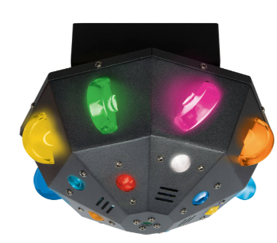

**Product Description and History**  
*(Brief Description and Background -- New, Replacement/Upgrade, any Links)*

*-----------------------------------------------------------------------------------------------------------------------------------------*

The Venue Mothership VP effects light is an upgrade and replacement for the Mothership. This effects light serves to add excitement to a light show through a multitude of effects including lasers and skate wheel effects. It is able to be attached to trusses or stand independently on its feet, making them versatile in application. The built-in show and mic allow the lights to follow the beat of the music, even without a DMX controller. There is a VenueLink Port on the back panel of these lights that allow for wireless transmission of DMX commands from a Tetra Control 2.

**Product Series Information**  
*(Does the product(s) belong to a series or family of products in a brand?)*  
*-----------------------------------------------------------------------------------------------------------------------------------------*

This is part of the Venue Lighting assortment that is being updated to work with wireless DMX.

The Mothership is already top selling effects lights and will now be compatible with wireless DMX commands sent by a Tetra Control 2 through a VenueLink dongle. The Tetra wash lights operate with the same dongle and controller.

**= THE CUSTOMER =**

**Target Customers**  
*(Describe the target customer or list the types of customers that would identify with this product(s). Describe why they find this product great for their needs. Is there any marketing research findings?)*

*-----------------------------------------------------------------------------------------------------------------------------------------*

* Mobile DJ’s – Easy, convenient, and quick setup. Can operate wirelessly.
* Bands – Easy, convenient, and quick setup. Can operate wirelessly.
* Small Venue – Easy, convenient, and can be hung on truss. Can operate wirelessly.

**Product Use**  
*(What are the use cases for this product?)*

*-----------------------------------------------------------------------------------------------------------------------------------------*

The customer is a performer or venue designer looking for versatile lighting for small-sized gigs. The lights can exist as permanent fixtures or be transported and set up easily. The effects lights are used for the patterns they create, not for their light output, so they are useful in smaller venues. Effects lights can be used by all types of performers but will most likely be purchased by DJs that want to add additional effects on top of existing wash light rigs, making them more experienced customers.

**= THE DETAILS =**

**Main Features (Must Have)**  
*(What are the 4 most important features in order of importance? What types of pictures would convey the features? [Insert Examples])*  
*-----------------------------------------------------------------------------------------------------------------------------------------*

1. No wires. Users can send commands to the lights up to 100 feet without the need for expensive DMX cables if they use a dongle.

*Back panel shot showing VenueLink port*

1. Lasers effect

*Laser effect image (same as current)*

1. Skate wheel effect

*Skate wheel glow image (same as current)*

1. Built in Auto-programs

*Composition video of auto show with all effects*

**Secondary Features (Nice to Have)**  
*(What are the 3 secondary features in order of importance? What types of pictures would convey the features? [Insert Examples])*  
*-----------------------------------------------------------------------------------------------------------------------------------------*

1.

2.

3.

**= THE COMPETITION =**

**Key Differentiators to the Competition**  
*(Who are the competitors for this product Explain why this product is better than competition, such as price or features. What do users dislike about the product?*  
***Please, do NOT reference this section in any of your copy.)***

*-----------------------------------------------------------------------------------------------------------------------------------------*

The main competition is the ColorKey Kraken and the Chauvet Swarm. The Chauvet Swarm does not have a moving head, limiting how dynamic it can be. The Color Key Kraken has a moving head but does not have as many varied effects as the Mothership.

**= THE WORDS =**

**Suggested Web and Messaging**  
*Elevate your guitar with Proline HANG, where protection meets style.*  
*-----------------------------------------------------------------------------------------------------------------------------------------*

**One liner**

The Mothership VP is a moving head effects light that can add movement and excitement to a show or set through its built-in chases, wired DMX, or wireless DMX.

**Paragraph**

The Venue Mothership VP is an effects light that serves to add excitement to a light show through its various effects including lasers and a skate wheel. It is able to be attached to trusses or stand independently on its feet, making them versatile in application. The built-in show and mic allow the lights to follow the beat of the music, even without a DMX controller. There is a VenueLink Port on the back panel of these lights that allow for wireless transmission of DMX commands from a Tetra Control 2.

**3 Bullet**

1. Skatewheel and laser revolving effects
2. Built-in auto shows with mic
3. VenueLink DMX wireless connection and standard wired DMX connection

**2 Bullet**

1. Skatewheel and laser revolving effects
2. Multiple options for control through built-in chases, wired DMX, or VenueLink wireless DMX

**Product Positioning Statement (PM + Dar)**  
*(For [target Customers] who [statement of the need or opportunity], the [product name] is a [product category] that [statement of benefit/compelling reason to buy]. Unlike [primary competitive product], our product [statement of primary differentiation].)*  
*-----------------------------------------------------------------------------------------------------------------------------------------*

For mobile DJs, bands, and small venue operators who need a dynamic, easy-to-set-up, and wireless-capable lighting solution to enhance their performances, the Venue Mothership VP is a moving head effects light that adds movement and excitement to any show through its built-in chases, laser and skate wheel effects, and VenueLink wireless DMX compatibility. Unlike the Chauvet Swarm, our product features a moving head for greater dynamism, and unlike the ColorKey Kraken, it offers a broader range of effects for a more engaging and versatile light show.

**Baseline Copy (Dar)**  
*(100 – 250 Words for outfacing tactics)*  
*-----------------------------------------------------------------------------------------------------------------------------------------*

Venue Mothership VP – The Ultimate Moving Head Effects Light

**Electrifying Effects for Unforgettable Shows**

The Venue Mothership VP is the ultimate moving head effects light, designed to bring electrifying energy and dynamic movement to any performance or event. Whether you’re a mobile DJ, band, or small venue operator, the Mothership VP delivers a stunning array of effects, including mesmerizing laser beams and skate wheel visuals, ensuring an unforgettable light show every time.

**Wireless Control for Effortless Setup**

Built for convenience and versatility, the Mothership VP features VenueLink wireless DMX compatibility, allowing you to control and sync multiple lights without the hassle of cables. Its built-in auto programs and sound-active mode let the lights respond to music effortlessly, creating seamless, pulse-pounding visuals with zero programming required.

**Versatile Mounting for Any Stage or Venue**

Need flexibility? The Mothership VP can be mounted on a truss or placed independently, adapting to any stage or venue setup with ease. Whether you’re performing in a club, concert hall, or private event, this light fits seamlessly into your rig.

**Dynamic Motion for Professional-Grade Impact**

With its powerful moving head, the Mothership VP delivers enhanced motion and dynamic effects, elevating your performance beyond standard static lighting. DJs, bands, and event hosts can now add depth, movement, and a professional touch to their shows with ease.

**No Wires. No Limits. Just Pure Visual Magic.**

Take your lighting game to the next level with the Venue Mothership VP—where cutting-edge technology meets high-impact performance.

**FEATURES**

* Distinctive LED colors – individual Red, Green, Blue, Amber, White, Pink, Cyan, and Yellow diodes
* X-Axis motorized rotation to scatter light effects
* “Skate Wheel Lens” unique column effect and wide coverage green laser
* 4 built-in auto programs with sound-active mode to follow the beat of the music
* Includes rubber feet for floor standing and a mounting bracket for truss mounting
* Wired DMX compatibility for seamless system integration
* Port for VenueLink DMX dongle for wireless control

**Packaging**  
*-----------------------------------------------------------------------------------------------------------------------------------------*

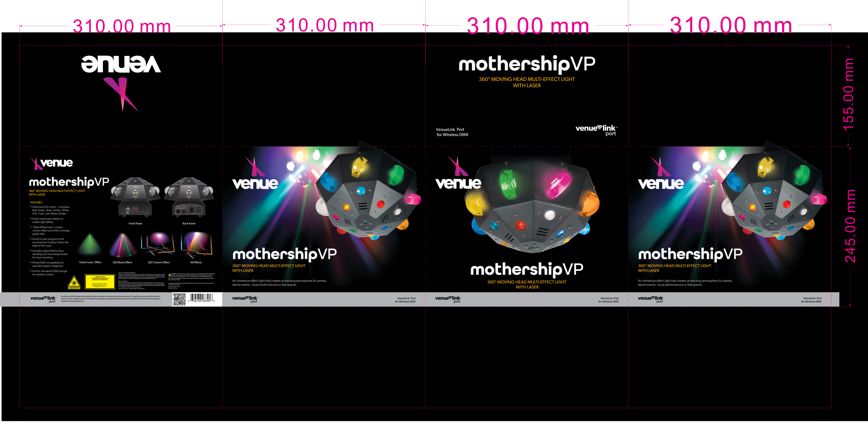

**= THE IMAGES =**

