ePDP Content for Simmons Titan 70
Simmons Titan 70 Electronic Drum Kit with Bluetooth
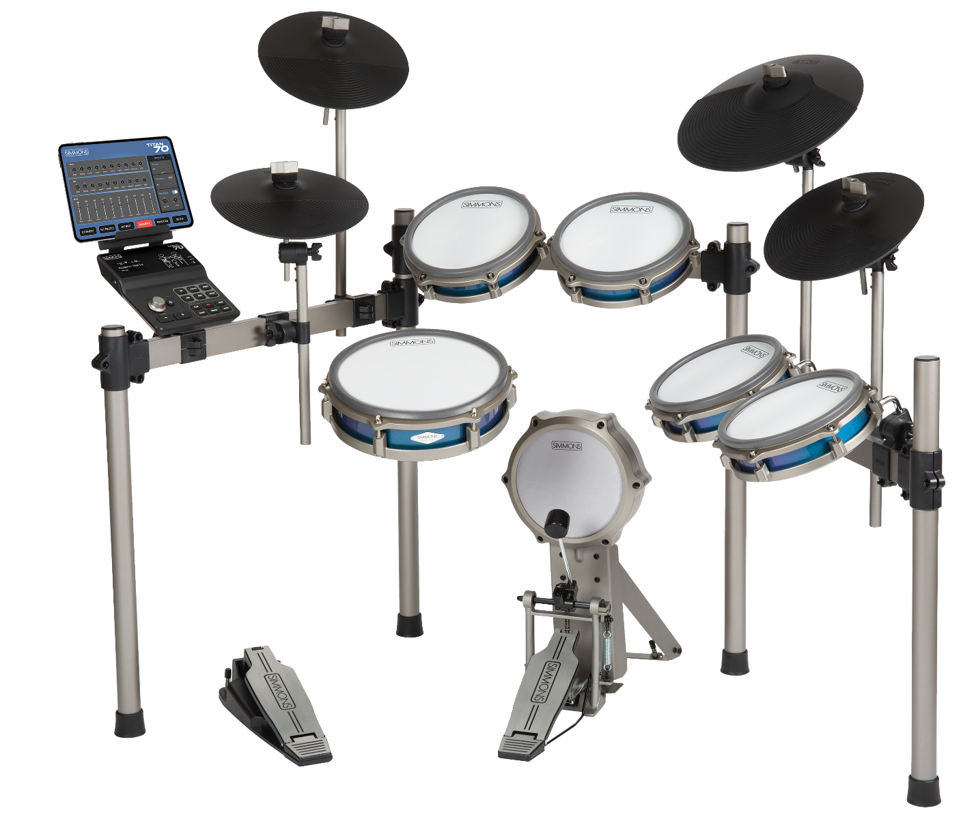
Overview/Product Description
Simmons’ Titan 70 builds on our Titan series of electronic drum kits and delivers the sound, feel, and innovation demanded by serious drummers. This full-sized kit includes multi-zone pads for expressive and responsive performance, album-ready produced sounds, and interactive features to customize the kit and improve timing accuracy for beginners to advanced players.
The kit is centered around a sensitive 10” dual-zone mesh snare pad with accurate rimshot detection. Four dual-zone mesh tom pads include rim sensors for assigning alternate sounds like percussion. Its three-zone ride is another highlight, the 12” cymbal includes sensors on the bow, bell, and edge crash for a variety of sounds. The hi-hat is controlled by a variable pedal for closed, open, and every sound in-between. For dramatic accents, the two crash cymbals include a choke sensor. All pads have been designed with sensitivity and feel in mind, from the low-profile rims to the dynamic curve. And the versatile rack has rectangular steel supports to keep pads locked in place.
The Titan 70’s acoustic drum sound library was newly-recorded in a renowned pro studio, and the stereo big room ambience can be heard on nearly all of the kits, snares, and cymbals. Samples were taken at different dynamic levels, and sounds ring out at their natural decay time. The result is a produced yet realistic and responsive drum sound.
Other features of the Titan 70 module include Bluetooth Audio and MIDI for wireless connection to mobile devices. Pair your phone or tablet and play along with videos and music through the same headphones or speakers as the drums. Bluetooth MIDI attaches to apps, like Simmons Drums 2 for iOS which selects kits, edits sounds and mixes, and plays music at slow speed to help learn new songs. The built-in, play-along practice mode also works with the app to work on timing accuracy, and the module includes a detachable, padded shelf for a phone or tablet.
From great-feeling pads with superior sensitivity, to superior-sounding kits and innovative interactive features, the Titan 70 is the ultimate launchpad for beginners, advanced and practicing drummers.

[Image: Close shot of snare and rack] | Full-sized Pads and Rack  A 10” responsive snare drum with rimshot detection captures every detail of your performance, and low-profile rims make the pads feel like a real kit. The 12” ride cymbal features separate zones for bow, bell, and edge crash sounds. The rectangular steel rack locks pads into place, and you can expand the width to accommodate the optional expansion pack.
Full-Length Sounds with Stereo Ambience  Simmons recorded a new drum library for the Titan 70 for a big, produced sound. Nearly all sounds have stereo room ambience and decay naturally. The result is a bank of high-quality, fun-to-play kits covering styles like rock, pop, and metal. | [Image: Photo from the sampling session? Someone playing the kit in headphones?]
[Image: Close view of module showing the Bluetooth LED] | Bluetooth Audio and MIDI  The Titan 70 module makes it simple to wirelessly connect to videos and apps. Bluetooth Audio plays your devices sound through the same speaker or headphones as your drums, so you can play along with music. Bluetooth MIDI works with smartphones and tablets with educational apps or our own Simmons Drums 2
Simmons Drums 2 App  Simmons’ own iOS app helps you select a kit, then edit the sounds and mix to your own style. Keep track of your progress with the built-in practice mode, or play songs from your song library at slow speed to learn new music. | [Image: iPad running the app sitting on the module shelf]  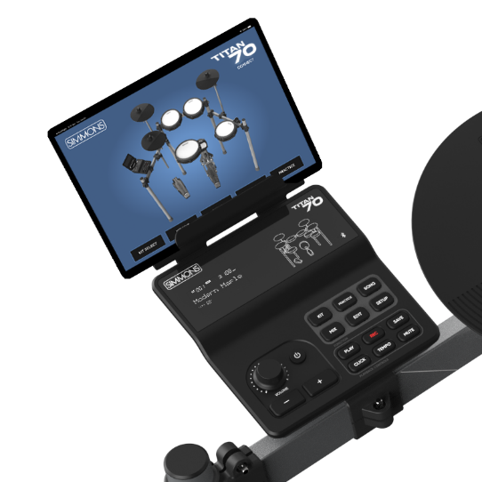

Features and Specifications
Features
- High-definition, full-length sounds with stereo room ambience powered by Simmons (Variable Attack Response) technology for expressive dynamics and realistic performance.
- Large 10-inch dual-zone, responsive mesh snare with rimshot detection
- Four 8-inch dual-zone toms with low profile rims and rim sensors
- 12” three-zone ride cymbal with bow, bell, and edge crash zones
- Bluetooth MIDI Control for editing the module using Simmons app and working with compatible music/drum apps.
- Bluetooth Audio compatible with computers, smart phones, and tablets for wireless audio connection to the module.
- Steel, full-sized, sturdy rectangular rack, and adjustable clamps to keep everything locked in place while playing
- Easy to use sound editing, play-along and practice tools
Drum Specifications
- Dual-zone, 10" tension-able mesh snare pad with rimshot detection
- Four 8” mesh dual-zone toms
- 10" hi-hat cymbal with variable pedal
- Two 10” crash cymbals with choke sensor
- 12” three-zone ride with bow, bell, and edge crash zones and choke sensor
- Dual layer, durable mesh heads with natural playability and high sensitivity
- Variable Hi-hat controller with sounds from closed to mid and open
- Kick pedal with 7” kick pad, optimized for single and double-kick pedals
- Included adjustable kick drum pedal
Module Specifications
- 75 Preset and User Drum Kits
- 4 Preset and 6 User Songs
- 314 Drum Sounds
- Practice Mode measures timing accuracy with several songs, exercises, and scoring
- Custom LED and Drum Kit LED indicators for simple editing and setup
- Bluetooth Audio and MIDI
- USB Audio and MIDI – Functions as a 2x2 audio interface with MIDI I/O
- Detachable, padded Tablet shelf securely holds iPhone, iPad, and other devices during practice
- Two dual-zone ¼” inputs for pad expansion
- 1/8” stereo aux input
- Stereo ¼” line outputs
- 1/8” stereo headphone output

